Yolov5 reproducibility

1. **Models and algorithms used**

Model used: <https://github.com/ultralytics/yolov5>

Pre-trained Weights used: yolov5m.pt

1. **Assumptions**

We assume a bounding box of 10px * 10px for each individual cell with a single pixel in the middle as true annotation

1. **Dataset used**

The dataset used is IDCIAv2 provided by the course COMS 571X as part of the final group project.

Details of train/test/validation split

| **Dataset** | **# cells** | **% cells** | **# image** | **% images** | **avg cell per image** | **Std** |
| --- | --- | --- | --- | --- | --- | --- |
| Train | 38987 | 78.64% | 199 | 79.60% | 195.9145729 | 199.5205251 |
| Validation | 4710 | 9.50% | 24 | 9.60% | 196.25 | 190.1052888 |
| Test | 5882 | 11.86% | 27 | 10.80% | 217.8518519 | 228.1847373 |

Additional details can be found on YOLOV5 All data excel spreadsheet. The train, test, and validation worksheet contains the exact names of the images that are in each split.

No data was excluded.

Link to the downloadable dataset: <https://canvas.iastate.edu/courses/101055/pages/requirements-and-resources?module_item_id=5813471>

1. **Code**

**4.1 Specifications of dependencies**

<https://github.com/ultralytics/yolov5/blob/master/requirements.txt>

**4.2 Training Code**

Training code is in YOLOV5_EXP.ipynb You only need to run the code until the line !zip -r result.zip /content/yolov5/runs/train/exp/

**4.3 Evaluation Code**

Evaluation code is in Evaluation.ipynb.

**4.3 Pretrained Models**

Pretrained model used: yolov5m.pt

This model can be found and downloaded from <https://github.com/ultralytics/yolov5>

**4.4 Readme File**

Readme file called Readme.docx contains precise commands to run training and evaluation code

1. **Experimental Results**

**5.1 Hyperparameters**

The hyperparameters for each model could be found at YOLO Models > [Specific Model] > result > content > yolov5 > runs > train > exp > opt.yaml

**5.2 Exact number of training and evaluation runs**

Training 100 epoch

Evaluation N/A

**5.3 Specific measure or statistics used to report results**

Mean Absolute Error

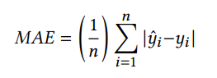

Acceptable Error Count Percent

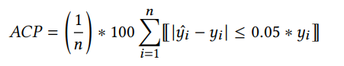

Inside Box Mean Absolute Error

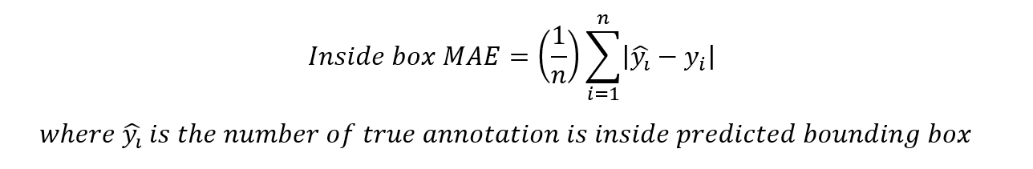

Inside Box Acceptable Error Count Percent

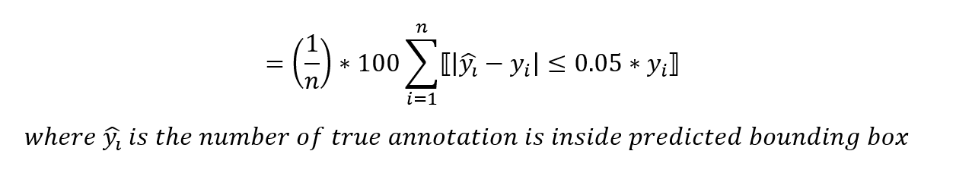

**5.4 Description of results**

Exact description of results could be found at YOLOV5 All data excel spreadsheet on the experimental result worksheet

**5.5 Average runtime for each result**

Average training time 30 min (With GPU)

Average evaluation time 10 min (Without GPU)

**5.6 Computing infrastructure used**

Google Colab

12.7 GB RAM

107.7 GB Disk

Nvidia Tesla T4